Looking ahead at HVAC industry trends to watch in 2019

A Q&A with Modine Vice President Scott Miller

As 2018 comes to an end, it’s natural to look ahead and ponder what the new year will have in store for the HVAC industry. We turned to Scott Miller, Modine Vice President-Building HVAC Group, to offer his take on the trends that will continue transforming the industry in the months ahead.

Question: What are the top three trends you see for the HVAC industry in 2019?

Answer: The three important HVAC industry trends that I see for 2019 are: No. 1, connectivity; No. 2, smart design; and No. 3, the ongoing shift in our distribution models.

What is the importance of connectivity?

As we look into the future, our equipment must be able to talk back to the consumer and system owner, to be able to communicate information — whether it’s about historical performance, efficiency, or what’s happening now. We take that all the way to self-diagnostics. The equipment must monitor itself and report when something might need attention. Multiple units could work together to compensate if one was running poorly or make sure they are all working together in the most-efficient manner for the customer.

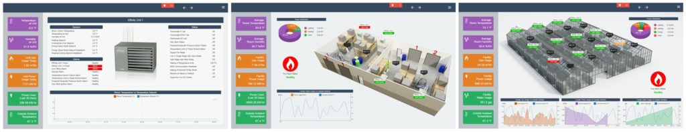

The Modine BMS monitoring system offers building owners unprecedented control over their heating units, all at the tip of their fingers through the customer’s BMS interface

What do you mean by smart design?

Equipment now needs to be able to monitor itself, diagnose what is happening, and be able to report out. We are designing products with the intention to provide proactive or forward-looking information that we’ve never had before. We’re designing the equipment to be able to talk to us and let us know when something might be failing. In some cases, it would allow us to extend the life of the product. We want our equipment to be able to have a digital dialogue with anybody.

How are HVAC industry distribution models changing?

There is an on-going shift in our traditional distribution models, how we get our product to market. The web is going to continue to have an effect on that. Our current distribution models have a significant element of face-to-face relationships and direct contact with customers. Those are all good things, and we try to leverage our business with that. Building positive relationships helps sell our products and helps us keep our customers happy.

But, selling via the web — that channel is going to continue growing in importance. We must be able to balance that with our traditional model as time goes on Our ability to connect with customers effectively in both models will be the key to our success.

What sectors in the HVAC industry will continue growing in 2019?



Classmate in Semi-Anechoic Sound Room w-employees

We think that 2019 will be another solid year across the board in all our sectors. We’re bullish on data center builds. That’s a sector that continues to grow at above-market rates. We’re really excited about the longer-term future for that. We do a lot of work in the educational facility market. There is good consistent growth, tied to bond approvals and where school districts are going to spend on infrastructure. We see that continuing.

An emerging market for HVAC applications is the industrial growing market — where products are grown entirely indoors under artificial light. We believe that’s the next step beyond the greenhouse, which uses natural light. Companies can use indoor growing to produce anything from consumables to industrial-type products. We’re very excited about the growth potential of that market.

From:https://modinehvac.blog/looking-ahead-hvac-industry-trends-watch-2019/